QA Automation of Testings

Testing linked to the deployments to production. Automating the complete testing process executed in each ordinary or extraordinary deployment to production.

*Each deployment to production is critical and a number of changes are done in the different systems, services and applications that involve the distribution of Transfers, Activities, Car Rental, Insurance and other products. For those reasons the team performs a set of general tests that all together provide a percentage of confidence that the overall platform to distribute works correctly.This document provides details on the different testing platforms and distribution channels for which testings are required.*

**Ammendment History**

|  |  |  |  |
| --- | --- | --- | --- |
| Version No | Date Of Issue | Author | Reason for Issue |
| 1.0 | 12-4-2015 | Facundo Rua |  |
|  |  |  |  |
|  |  |  |  |
|  |  |  |  |
|  |  |  |  |

**Table of Contents**

1. Scope 4

2. In Scope details 5

2.1 Hotelextras.com – Test content 5

2.1.1 Generic testing Activities 5

2.1.2 Particular testings per destination Activities 7

2.1.3 Generic testing Transfers 8

2.2 Hotelbeds.com – Test content 10

2.3 Bedsonline.com 10

2.4 GuideGo 10

2.5 Widgets Activities 11

2.6 Widgets Transfers 11

2.7 Hotelopia.com 11

2.8 CheckPickup.com 11

2.9 Yourparkcode.com 11

2.10 CheckPickup/suppliers 11

2.11 TUI Nordic XML integration including the payment 11

2.12 TUI UK XML version MAINSTREAM 12

2.13 TUI UK TDA XML version ARD_BETA 12

2.14 Mythomsontickets.com 12

2.15 Excursion.thomson.co.uk 12

2.16 Excursion.firstchoice.co.uk 12

2.17 FTP connections working 12

2.18 XML integration for Activities 12

2.18.1 Version ARD_BETA/DESPEGAR 12

2.18.2 Version Default 12

2.18.3 Version Version MAINSTREAM 12

2.19 XML integration for Activities 13

2.19.1 Version ARD_BETA/DESPEGAR 13

2.19.2 Version Default 13

# Scope

***In Scope***

*The testing done after each deployment to production as detailed in the Notebook of each deployment. A notebook example is given below:*

[*https://agile.tuitravel-ad.com/confluence/display/TAB/LU2015-04+Notebook*](https://agile.tuitravel-ad.com/confluence/display/TAB/LU2015-04+Notebook)

*The following distribution channels are considered:*

* *Hotelextras.com*
* *Hotelbeds.com*
* *Bedsonline.com*
* *GuideGo*
* *Widgets for Activties*
* *Widgets for Transfers*
* *Hotelopia.com*
* [*www.checkpickup.com*](http://www.checkpickup.com)
* [*www.yourparkcode.com*](http://www.yourparkcode.com)
* [*www.checkpickup.com/suppliers*](http://www.checkpickup.com/suppliers)
* *TUI Nordic XML integration including the payment*
* *TUI UK XML version MAINSTREAM*
* *TUI UK TDA XML version ARD_BETA*
* *Mythomsontickets.com (B2B TUI UK website)*
* *Excursion.thomson.co.uk (B2C TUI UK website)*
* *Excursion.firstchoice.co.uk (B2C TUI UK website)*
* *FTP connections for XML integrations*
* *XML integration for Activities Version ARD_Beta/Despegar*
* *XML integration for Activities Version Default*
* *XML integration for Activities Version MAINSTREAM*
* *XML integration for Transfers Version 2013/12*
* *XML integration for Transfers Version Default*

*The scope will cover the following products sold on the distribution channels mentioned before:*

* *Activities (Tickets & Excursions)*
* *Transfers*
* *Car Rental*
* *Insurance*

***Out of Scope***

*It is out of scope the implementation of automation for the accommodation product or any other product that is not detailed in the “In Scope” Section.*

*It is also out of scope any additional distribution channel or system nor detailed in the “In Scope” section.*

# In Scope details

## **Hotelextras.com – Test content**

The test plan consist of different casuistics and testing using different scenarios. The destinations to be tested are:

* Salou
* Barcelona
* Madrid

Although the web is the same for all destinations there are particular products in each destination. We will provide a general testing overview for the website regardless of the destination and then the particularities for the different destinations considering the specific product.

It is important to know that in Hotelextras there is no Destination to be selected and this is linked to the user name and password.

Also the user is linked to the model of selling in Hotelextras. There are two models:

* Model 1 - Commissionable
* Model 2 – Net

The difference between one and the other is that in the first model the commission is taken by the receptionist directly and there is no payments done using credit card.

In model 2, the receptionists commission is charged by Hotelextras together with the total amount of the ticket or excursion. The commission value is then paid back to the recepcionist.

The difference is also shown when you are about to book an excursion. See below:

|  |  |  |
| --- | --- | --- |
| Step in the booking funnel | Model 2 – Net | Model 1 – Commissionable or Net |
| Availability |  |  |
| ServiceAdd. See that the price is different in Model 2 from Service Add to purchase confirm. |  |  |

The price change depends on the idweb configured on the website.

### Generic testing Activities

Choose any product in any destination with any user and test the following:

1. **Availability tests:**
   * Pax distribution
     + 2 adults and 1 child
     + 1 adult
     + 2 adults and 3 childs
   * Today + 1 day
     + OK – Include information on total number of products returned
     + KO – issue on the availability no product being returned
   * Today + 3 months
     + OK – Include information on total number of products returned
     + KO – issue on the availability no product being returned
   * Today + 6 months
     + OK – Include information on total number of products returned
     + KO – issue on the availability no product being returned
   * Today + 12 motnhs
     + OK – Include information on total number of products returned
     + KO – issue on the availability no product being returned
2. **Product details (more information)**
   * Access the product more information and ensure that:

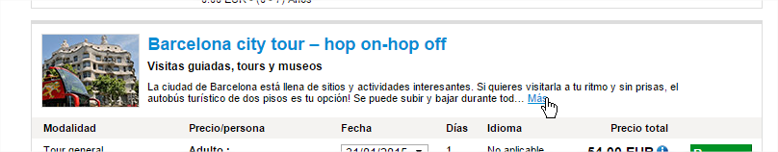

* + - There is information on the product and all images are there
    - Product is availabile and “Reservar” buttons are present and possible to be clicked to book the product.
    - There are no messages starting with WARN.

1. **Service Add – Reservar (agregar al carro de compra)**
   * Pax distribution for Service Add
     + 2 adults and 1 child
       - Age child 12
     + 1 adult
     + 2 adults and 3 childs
       - Age child 2 – 8 - 12
   * Service Add for the following products
     + For the product review the
       - Tour General (no senior or disabled)
       - Check price between availability and service add is the same
       - Check that the distrubtion of paxes is correct in the service add
       - Check that the date selected in the service add is correct
       - Check that the distrubtion of paxes is correct in the service add (important is to see the correct price which is the following
         * 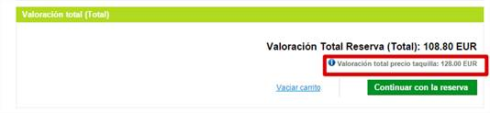
       - Check that the date selected in the service add is correct
2. **Confirm booking**
   * Pax name to be used: TEST / TEST FRUA
   * Referencia / Reference to be used: TEST FRUA
   * Confirm that price is the same as the valuation of the total booking. This price is 108.80 in the previous step
   * Pay by cash
   * Pay by credit card
3. **Voucher information**
   * Confirm that the total in the voucher is correct.
   * Confirm that for the product voucher is generated correctly. If it has a barcode then make sure that it is returned:
     + For the pax combination: 2 adults and 1 child – 2 paxes
       - Age child 12
     + For the pax combination: 1 adult – 1 pax
     + For the pax combination: 2 adults and 3 childs – 4 paxes
       - Age child 2 – 8 – 12
     + If no barcodes then is a KO
   * Pax distribution in the voucher same as availability and service add
   * Date of service same as the one selected in service add
   * Pax name same as in service add
   * No WARN messages present.

### Particular testings per destination Activities

#### Madrid

1. **Availability:**
   * Search availability
   * Select the Madrid CityTour Hop-on hop-off bus
   * Make a service add (Book) for 2 adults and 1 child 8 years old.
2. **ShoppingCart**
   * When added to the shopping cart please review the same controls as the ones detailed in the general testing
3. **Booking**
   * Review the same controls as the ones detailed in the general testing
   * Make a booking and review the voucher generated
4. **Voucher**
   * The voucher must have a barcode in it.
   * The barcode should have the following configuration of the barcode numbers:
     + (Jesus te paso esto luego. No los tengo aca a mano).

#### Salou

1. **Availability:**
   * Search availability
   * Select the PortAventura 2 days product
   * Make a service add (Book) for 2 adults and 2 child 8 years old and 3 years old
2. **ShoppingCart**
   * When added to the shopping cart please review the same controls as the ones detailed in the general testing
3. **Booking**
   * Review the same controls as the ones detailed in the general testing
   * Make a booking and review the voucher generated
4. **Voucher**
   * The voucher must have a barcode in it and should be one voucher for each person but there should not be a voucher for the 3 years old child.
   * The configuration of the barcode should be as follow:
     + Log in Salou. Look for PortAventura ticket and book it. Ensure that the barcode is there and that all values are correct based on the availability.
   * The barcode should have the following configuration of the barcode numbers:
     + User: Barcode codes to be checked depending on the booking done
       - 1 day general - 401
       - 1 day junior - 402
       - 1 day senior - 403
       - 1 day disabled – 432
   * Test sending the voucher through email and confirm reception.

#### Barcelona

1. **Availability:**
   * Search availability
   * Select the Barcelona CityTour Hop-on hop-off bus
   * Make a service add (Book) for 2 adults and 1 child 8 years old.
2. **ShoppingCart**
   * When added to the shopping cart please review the same controls as the ones detailed in the general testing
3. **Booking**
   * Review the same controls as the ones detailed in the general testing
   * Make a booking and review the voucher generated
4. **Voucher**
   * The voucher must have a barcode in it.
   * The barcode should have the following configuration of the barcode numbers:
     + (Jesus te paso esto luego. No los tengo aca a mano).

### Generic testing Transfers

Perform the following:

* **Availability: Search for availability using the following details:**
  + Pax distribution
    - 2 adults and 1 child
    - 1 adult
    - 2 adults and 3 childs
  + Today + 1 day
    - OK – Include information on total number of products returned
    - KO – issue on the availability no product being returned
  + Today + 3 months
    - OK – Include information on total number of products returned
    - KO – issue on the availability no product being returned
  + Today + 6 months
    - OK – Include information on total number of products returned
    - KO – issue on the availability no product being returned
  + Today + 12 motnhs
    - OK – Include information on total number of products returned
    - KO – issue on the availability no product being returned
  + Select the airport and the date choosing the time 10.00 am
  + Perform a booking with a Shared and a Private
    - For the Share:
      * 
    - For a Private:
      * 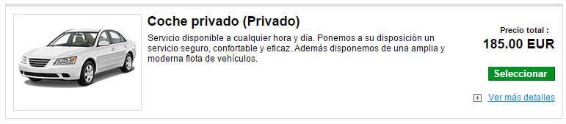
* **ShoppingCart:**
  + Service Add or Shopping Cart review the following:
    - Information of the transfer is the same between the avail and the service add
    - Check price between availability and service add is the same
    - Check that the distrubtion of paxes is correct in the service add
    - Check that the date selected in the service add is correct
    - Check that the distrubtion of paxes is correct in the service add (important is to see the correct price which is the following
      * 
    - Check that the date selected in the service add is correct for the service requested
    - Check that the following website appears in the description given before clicking on “Continuar Reserva”
      * *“Por favor accede a http://www.checkpickup.com/”*
      * 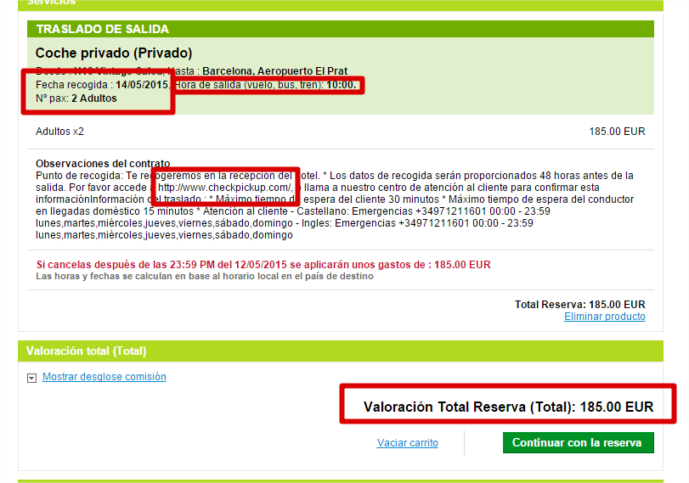
    - Check that the
* **Confirm booking**
  + Pax name to be used: TEST / TEST FRUA
  + Referencia / Reference to be used: TEST FRUA
  + Confirm that price is the same as the valuation of the total booking. This price is the same as in the avail and shopping cart in the previous step
  + Pay by cash
  + Pay by credit card
* **Voucher information**
  + Confirm that the total in the voucher is correct.
  + Confirm that for the product voucher is generated correctly. If it has a barcode then make sure that it is returned:
    - For the pax combination: 2 adults and 1 child – 2 paxes
      * Age child 12
    - For the pax combination: 1 adult – 1 pax
    - For the pax combination: 2 adults and 3 childs – 4 paxes
      * Age child 2 – 8 – 12
    - If no barcodes then is a KO
  + Pax distribution in the voucher same as availability and service add
  + Date of service same as the one selected in service add
  + Pax name same as in service add
  + No WARN messages present.
  + Ensure that the website appears in the confirmation voucher

## **Hotelbeds.com – Test content**

Review availability of the

1. **Availability tests:**
   * Pax distribution
     + 2 adults and 1 child
     + 1 adult
     + 2 adults and 3 childs
   * Today + 1 day
     + OK – Include information on total number of products returned
     + KO – issue on the availability no product being returned
   * Today + 3 months
     + OK – Include information on total number of products returned
     + KO – issue on the availability no product being returned
   * Today + 6 months
     + OK – Include information on total number of products returned
     + KO – issue on the availability no product being returned
   * Today + 12 motnhs
     + OK – Include information on total number of products returned
     + KO – issue on the availability no product being returned
2. **Product details (more information)**
3. **Service Add – Reservar (agregar al carro de compra)**
   * Pax distribution for Service Add
     + 2 adults and 1 child
       - Age child 12
     + 1 adult
     + 2 adults and 3 childs
       - Age child 2 – 8 - 12
   * Service Add for the following products
4. **Confirm booking**
5. **Voucher information**

## **Bedsonline.com**

## **GuideGo**

## **Widgets Activities**

## **Widgets Transfers**

## **Hotelopia.com**

## **CheckPickup.com**

In order to test the CheckPickup.com website do the following testings:

|  |  |  |
| --- | --- | --- |
| Test # | Detail of the test | Expected result |
| CKPICK1 | Open the website by accessing the following URL [www.checkpickup.com](http://www.checkpickup.com) | The following website opens correctly. |
| CKPICK2 | Add the following date: XX/XX/XXXX  Use the following Last Name “Apellidos”  And input the following booking number “Localizador de la reserve”  Click enter | The following booking details should be provided: |

## **Yourparkcode.com**

In order to test the YourParkCode.com website do the following testings:

|  |  |  |
| --- | --- | --- |
| Test # | Detail of the test | Expected result |
| PRKCOD1 | Open the website by accessing the following URL [www.yourparkcode.com](http://www.yourparkcode.com) | The following website opens correctly. |
| PRKCOD2 | Add the last name:  *CURTO*  Use the following booking number:  *235-2036446*  Click on Get Code | The following booking details should be provided: |

## **CheckPickup – Suppliers WebSite for Transfers**

In order to test the Suppliers Website for Transfers website do the following testings:

|  |  |  |
| --- | --- | --- |
| Test # | Detail of the test | Expected result |
| PRKCOD1 | Open the website by accessing the following URL [www.checkpickup.com/suppliers](http://www.checkpickup.com/suppliers) | The following website opens correctly. |
| PRKCOD2 | Login using the following credentials:  OTISA / OTISA  Click on Login | The following booking details should be provided: |

## **TUI Nordic XML integration including the payment**

## **TUI UK XML version MAINSTREAM**

This XML is only needed to confirm availability. No complete booking funnel is required here. So if we do perform the availability using a certain GPS coordinates and we are returned that should be enough. There are a few validations of tags being returned that are important.

Execute the following XML request:



Ensure that the following tags in the XML are present and contain information:

|  |  |  |
| --- | --- | --- |
| Tag | Why? | Comments |
| <URL>details/E-E10-002500132-loroparqueentranceonly</URL> | This tag is used by the client to do a deeplink to a website that we maintain. It is important to confirm that all services have the relevant URL value |  |
| <ContentFactSheet xsi:type="ProductTicket"> | Content factsheet returns all the relevant information required for our clients to present the product. This is mandatory to have |  |
| Within the content factsheet the following tags shall always appear:   * <Name> * <DescriptionList> * <ImageList> * <TicketPosition latitude="28.408317" longitude="-16.564722"/> * <OperationDays> * <Segmentation> * <CheapestPriceAdult> | The information is the minimum in this version of XML for our clients. |  |

## **TUI UK TDA XML version ARD_BETA**

## **Mythomsontickets.com**

## **Excursion.thomson.co.uk**

## **Excursion.firstchoice.co.uk**

## **FTP connections working**

## **XML integration for Activities**

### Version ARD_BETA/DESPEGAR

### Version Default

### Version Version MAINSTREAM

## **XML integration for Activities**

### Version ARD_BETA/DESPEGAR

### Version Default